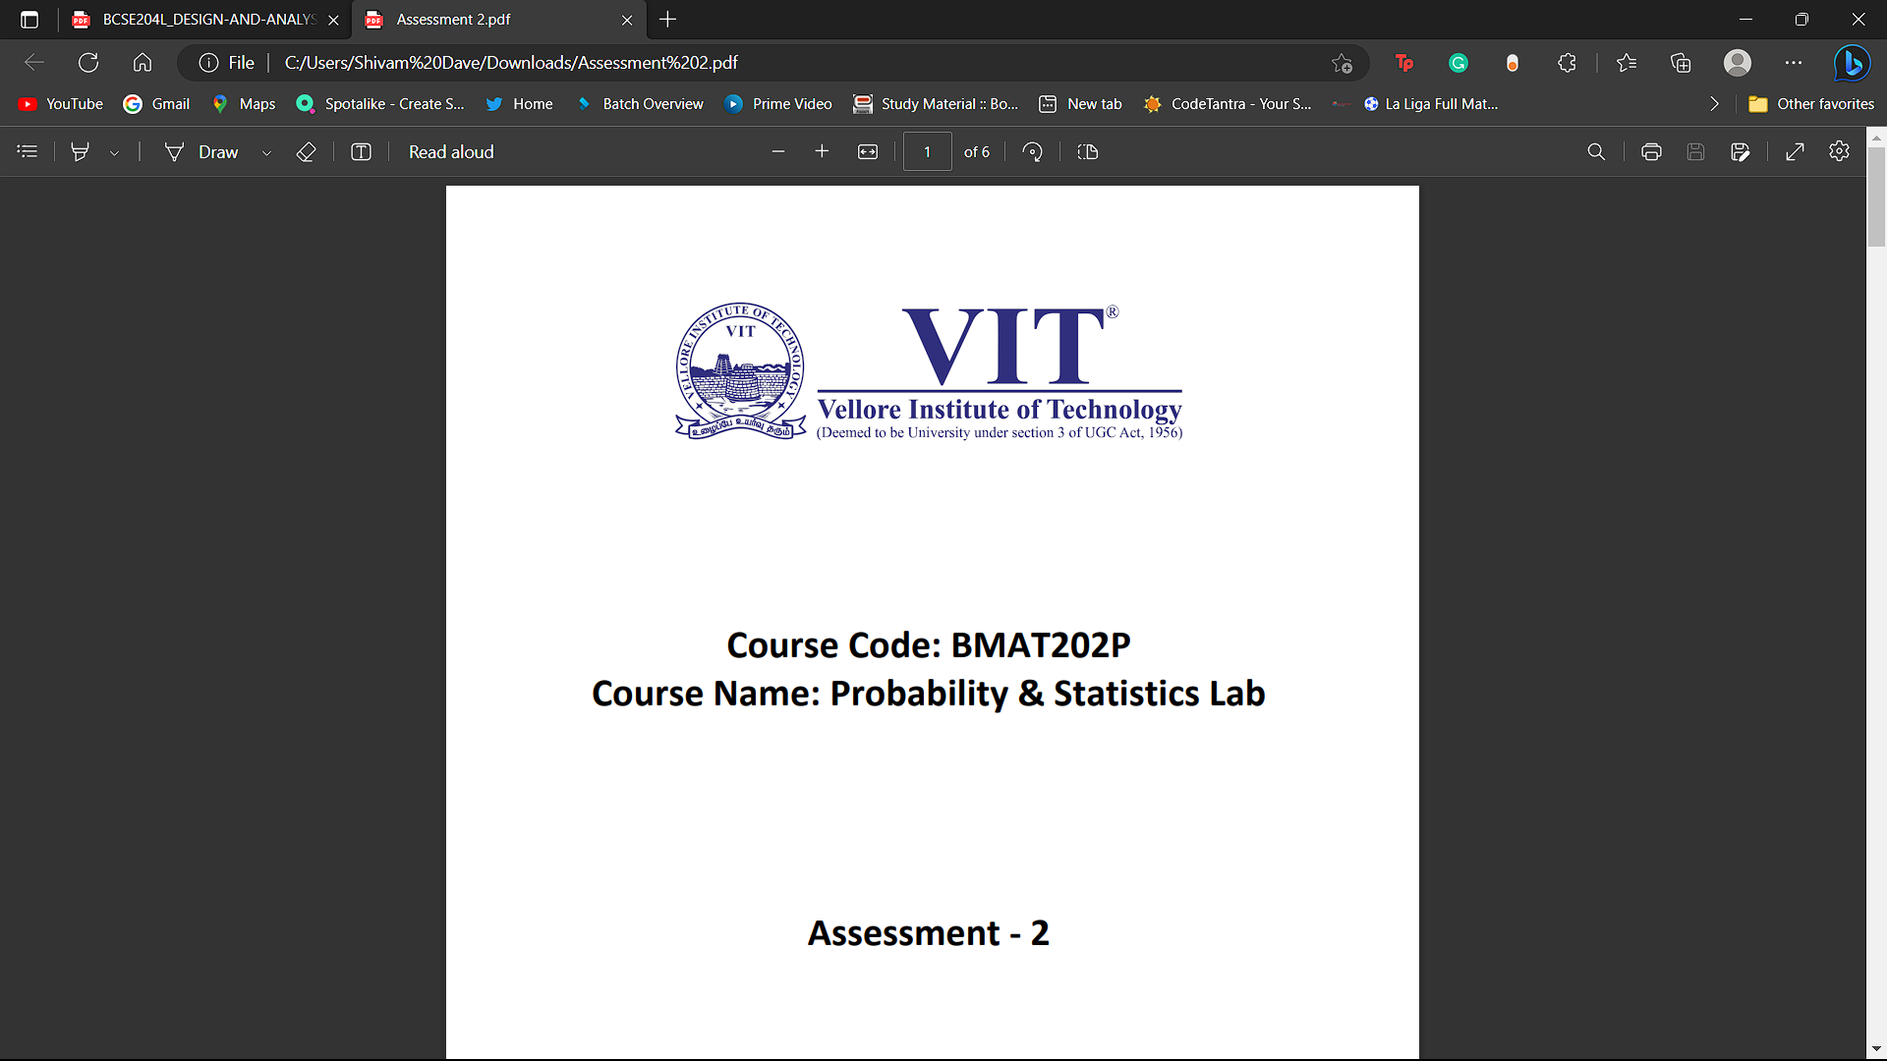 **Course Code: BCSE353E**

**Course Name: Information Security Analysis and Audit**

**Assessment – 3**

**Name: Shivam Dave**

**Reg. No.: 21BCB0107**

**Cisco Packet Tracer to simulate a firewall**

**Step 1:** First, open the Cisco packet tracer desktop and select the

devices given below:

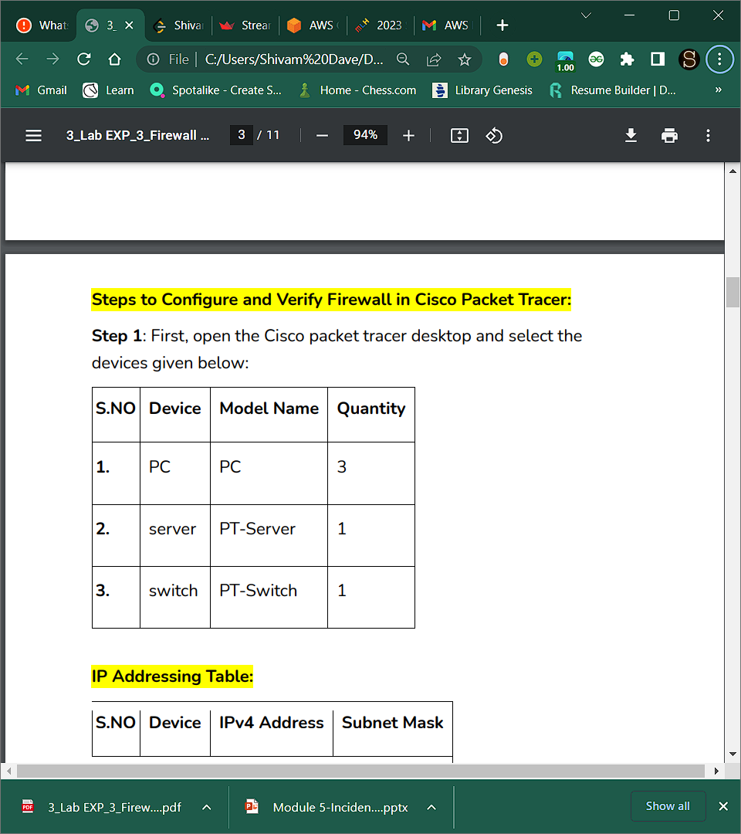

IP Addressing Table:

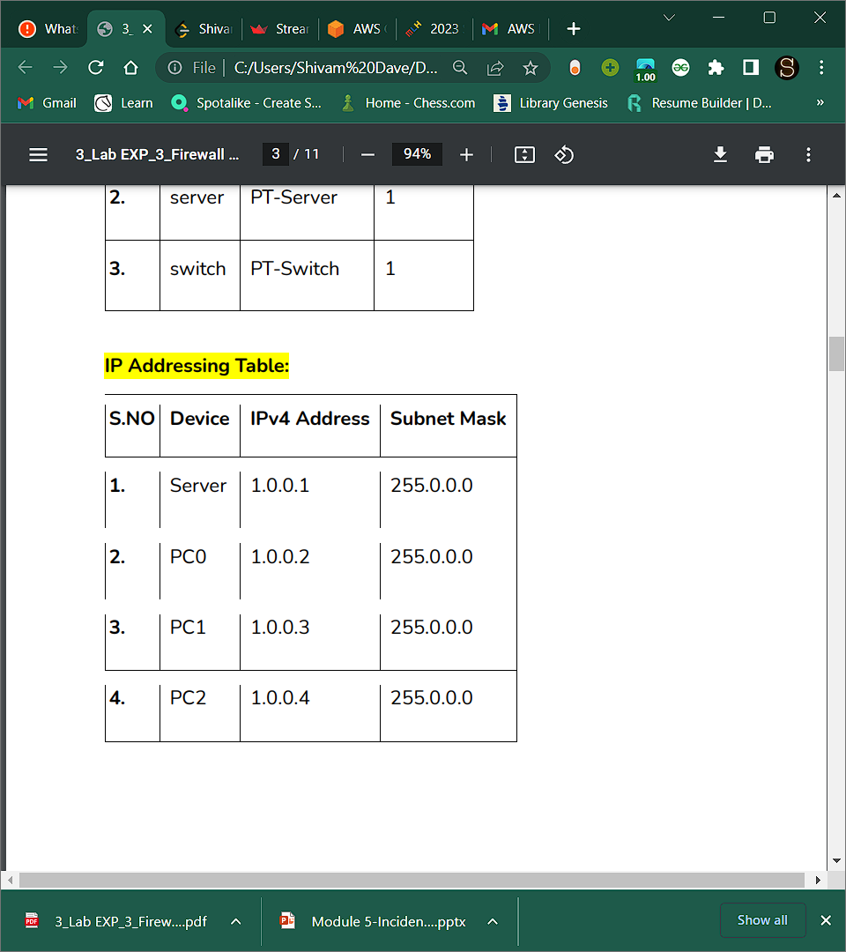

Then, create a network topology as shown below the image.

Use an Automatic connecting cable to connect the devices with

others.

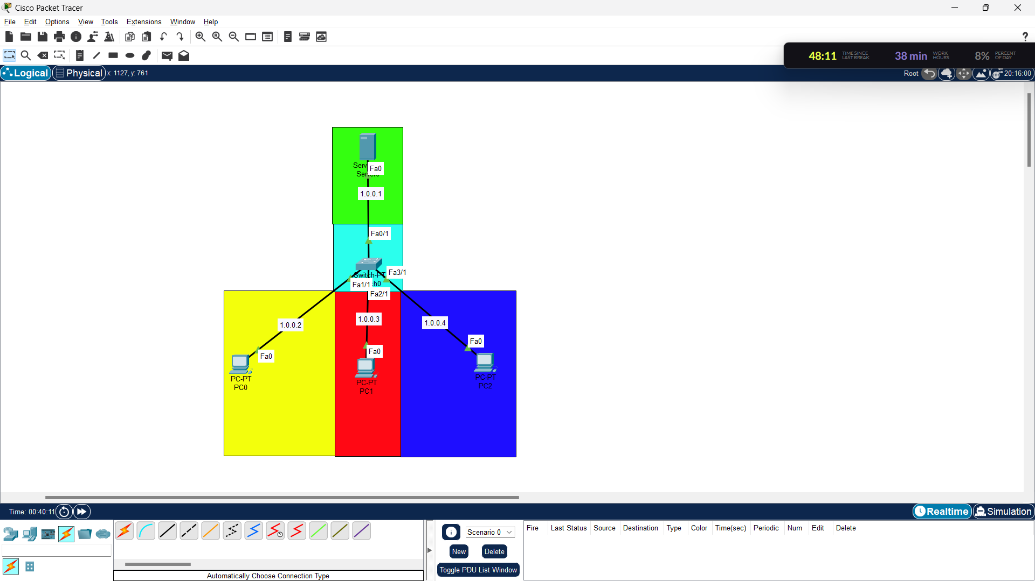

**Step 2:** Configure the PCs (hosts) and server with IPv4 address and

Subnet Mask according to the IP addressing table given above.

* To assign an IP address in PC0, click on PC0.
* Then, go to desktop and then IP configuration and there you will

IPv4 configuration.

* Fill IPv4 address and subnet mask.
* Repeat the same procedure with the server

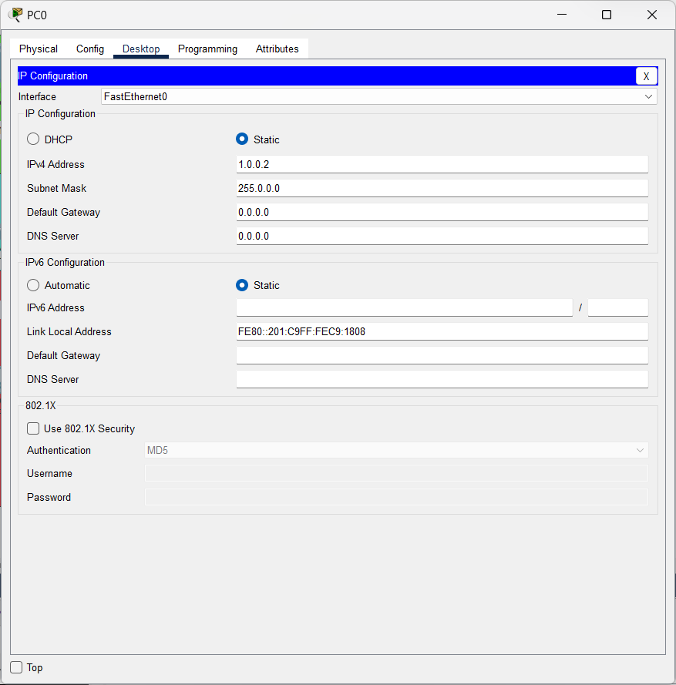

**Step 3**: Configuring the firewall in a server and blocking packets and

allowing web browser.

* Click on server0 then go to the desktop.
* Then click on firewall IPv4.
* Turn on the services.
* First, Deny the ICMP protocol and set remote IP to 0.0.0.0 and

Remote wildcard mask to 255.255.255.255.

* Then, allow the IP protocol and set remote IP to 0.0.0.0 and

Remote wildcard mask to 255.255.255.255 and add them.

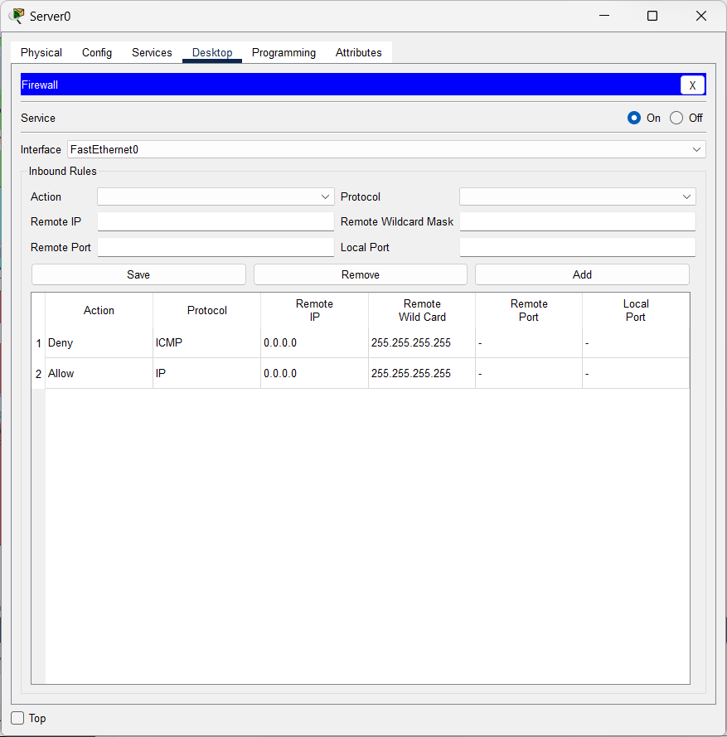

**Step 4:** Configuring the firewall in PC0 and verifying:

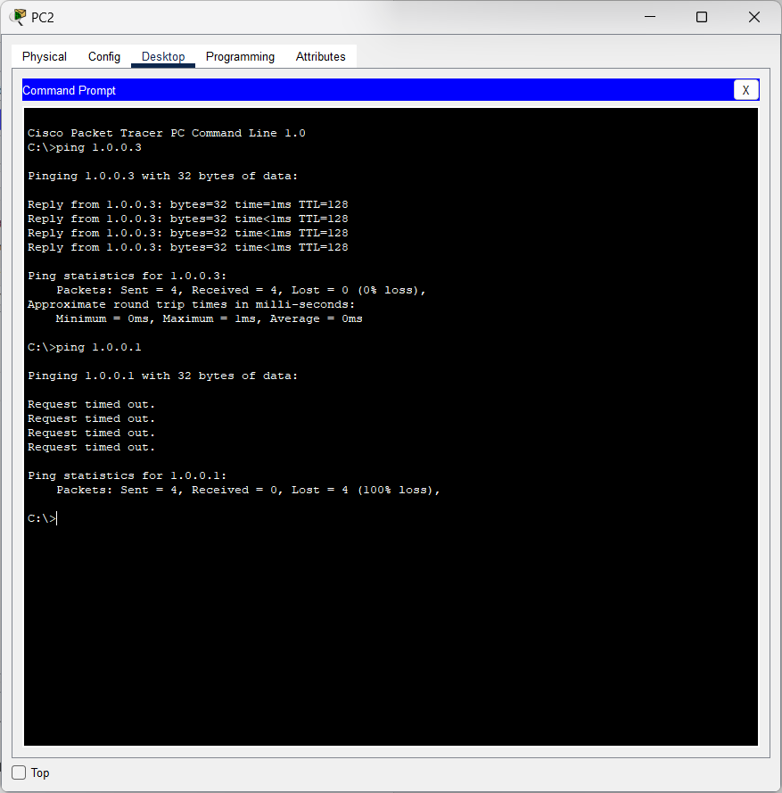

Hence Verified as we get reply from the 1.0.0.3 IP ping but not from 1.0.0.1 .